**Usage of Azure Devops Repo Certificate Scanner**

This scanner is a C# console application that connects to azure devops (ADO) programmatically using the PAT (personal access token) and searches for the keywords you input like (certificate, serialnumber, certificate name)

The response of the findings will be saved as excel file and each workbook in the excel file will be each search input string.

This console application uses the API provided by the DSRE/ADO team - [https://almsearch.dev.azure.com/{0}/{1}/_apis/search/codesearchresults?api-version=5.1-preview.1](https://almsearch.dev.azure.com/%7b0%7d/%7b1%7d/_apis/search/codesearchresults?api-version=5.1-preview.1) to programmatically search the string.

Features of the scanner:

* Eases the solution with default input parameters and giving option to change it.
* Takes multiple search input strings in comma separated
* Search the keywords in specific filetypes in comma separated or mention * for all filetypes
* Saves the response of each search keyword in an individual excel workbook to ease the response

Follow the below steps to scan the repo.

1. Download the solution from github and save it locally
2. PAT is the token created by Azure devops and used for accessing the repo. If you don’t have PAT token already you can create one at <https://microsoftit.visualstudio.com/_usersSettings/tokens>
3. Open the saved solution in VS 2019 or above.
   1. Press ‘F5’ to build and compile the code
   2. It should build the code successfully and compiles the code to open a command prompt

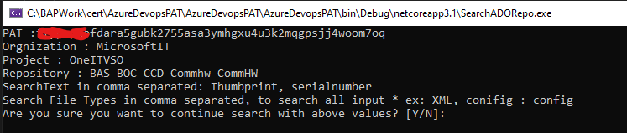

* 1. Verify if the default inputs are what you wanted to search. If not Enter ‘N’
  2. If you enter N, enter the values you want to search for parameters
  3. If you have entered Y, it starts searching the keywords using API
  4. It shows where the result excel file is saved, how many results found for each keyword

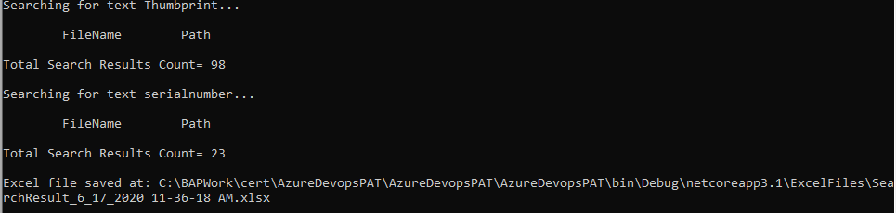

* 1. Copy the path of result excel file to open.

1. When you open the results excel file you might see multiple tabs, and each represents each search key word’s result.
2. It has two columns ‘FileName’ and ‘FilePath’ in each workbook. It gives information like the filepath and in which file when it matches the keyword.